**Instructions**

Thanks for agreeing to be a note-taker / co-ordinator!

**My aim is to come away with management strategies for each of the starting points** (see ringed states on chart below), **hopefully also with variations suitable for heavy *vs* medium soils** (and maybe light soils too if time/interest), **and for northern/ midland/ eastern regions**.

Please ensure that the main, grey-filled, sub-headings of the table (crop, stale seedbed, tillage, etc.) are filled in at a minimum.

After that, timings and amounts of stuff applied are the most important.

The models I’m using do require the greater levels of detail on this sheet, so please try and ensure that they are filled in. However, I’ll leave it up to you whether you insist on getting them *vs* annoying the participants or interrupting useful discussion where you can take notes which may lead to alternative scenario creation.

I’ve done enough columns for 6 years’ cropping. If you need more, please just continue on spare sheets, clearly identifying which management strategy they are linked to.

Please also take notes during the discussion within your group, to capture any innovative thinking or alternative strategies that might not end up being used as the main strategy the group decides on.

The diagram below is there to clarify which baseline(s) and which geo-physical conditions we’re creating a management strategy/strategies for.

**Region**

Northern / central / eastern

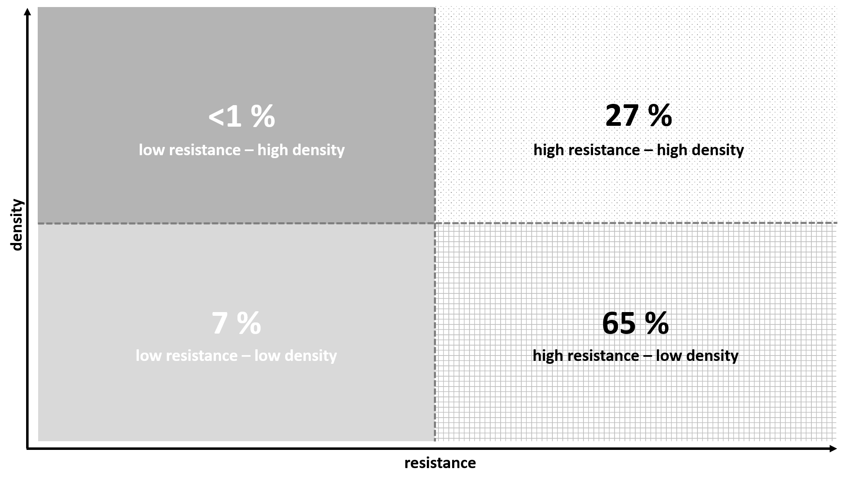

**Soil type**

Heavy / medium / light

**Region**

Northern / central / eastern

**Soil type**

Heavy / medium / light

**Soil type**

Heavy / medium / light

**Region**

Northern / central / eastern

**Thank you!**

|  |  |  |  |  |
| --- | --- | --- | --- | --- |
| **Baseline situation**  (*i.e.* **A**, low resistance, low-med density; B, high resistance, low-med density; or **C**, high resistance, high density) | | | | |
| **Location, soil type**  (*i.e.* region could be ***North***/central/East etc. Soil type ***heavy/medium***/light) | | | | |
| **Aims of management strategy**  (e.g. reduce black-grass density, or prevent further resistance developing, etc.  Encourage them to make it explicit; if they don’t, no worries). | | | | |
| **MANAGEMENT STRATEGY** | | | | |
|  | **example** | **Year 1** | **Year 2** | **Year 3** |
| **Crop** | ww | Winter Wheat | Winter barley | Spring Beans |
| seed rate (kg/ha) | 195 |  |  |  |
| sowing window | end Oct – mid Nov | Early – Mid October | Late Sept / early October |  |
| **Stale seedbed?** | yes | Yes | Yes | Yes |
| reps | 2 |  |  |  |
| management | * Disc (7.5cm depth) * Glyphosate mid Sep 540g ai (0.5 l/ha) * Roll 3 days later * 3 weeks later (*e.g.* 5th Oct), 2nd glyphosate 540g ai (0.5 l/ha) | 2 glyphosate sprays (540g ai/ha)  Early sept + early October | 2 glyphosate sprays (540g ai/ha)  Early sept + early October | 2 glyphosate sprays (540g ai/ha)  Early sept + early October |
| **Tillage** | Non-inversion | Non-inversion / Direct drilled | Non-inversion / Direct drilled | Non-inversion / Direct drilled |
| type 1 | disc |  |  |  |
| date 1 | late Sep |  |  |  |
| depth 1 (cm) | 7.5 |  |  |  |
| type 2 | subsoil |  |  |  |
| date 2 | late Sep |  |  |  |
| depth 2 (cm) | 25 |  |  |  |
| type 3 |  |  |  |  |
| date 3 |  |  |  |  |
| depth 3 (cm) |  |  |  |  |
| **Fertiliser** | Total [N] = 200kg/ha | As standard | As standard | As standard |
| type 1 | Ammonium nitrate |  |  |  |
| date 1 | end Feb |  |  |  |
| amount 1 (kg[N]/ha) | 40 |  |  |  |
| type 2 | Ammonium nitrate |  |  |  |
| date 2 | end Feb |  |  |  |
| amount 2 (kg[N]/ha) | 80 |  |  |  |
| type 3 | Ammonium nitrate |  |  |  |
| date 3 | end Feb |  |  |  |
| amount 3 (kg[N]/ha) | 80 |  |  |  |
| **Herbicide regime** |  |  |  |  |
| Product/active 1 | Liberator | Triallate (avadex) | Liberator | Stomp |
| Date 1 | early Oct | Pre-em | Pre-em | Pre-em |
| Amount 1 (l/ha) | 0.6 | 15kg/ha | 0.6 l/ha | 4 l/ha |
| Product/active 2 | Atlantis + Liberator | Crystal | Defy | Linuron |
| Date 2 | mid Nov | Pre-em | Pre-em | Pre-em |
| Amount 2 (l/ha) | Atl 0.4, Lib 0.3 | 4.0 l/ha | 4 l/ha | 1.35 l/ha |
| Product/active 3 |  | Liberator |  |  |
| Date 3 |  | 14 days after sowing |  |  |
| Amount 3 (l/ha) |  | 0.3 l/ha |  |  |
| Product/active 4 |  |  |  |  |
| Date 4 |  |  |  |  |
| Amount 4 (l/ha) |  |  |  |  |
| Product/active 5 |  |  |  |  |
| Date 5 |  |  |  |  |
| Amount 5 (l/ha) |  |  |  |  |
| Product/active 6 |  |  |  |  |
| Date 6 |  |  |  |  |
| Amount 6 (l/ha) |  |  |  |  |
| **Notes**  e.g.   * what happens to **straw** and why? * **Cover crop**? If so, details and why. * Anything else to note? |  |  |  |  |

**NB:**

Tillage - important to differentiate between inversion (to bury new seeds) and non-inversion each year

Herbicides - I only require herbicides targeting Black-grass, and glyphosate applications for stale seedbed (*i.e.* don’t include glyphosate applications used for crop desiccant, or herbicides that target broad leaved weeds, or adjuvants etc. etc.)

|  |  |  |  |  |
| --- | --- | --- | --- | --- |
| **Baseline situation**  (*i.e.* **A**, low resistance, low-med density; **B**, high resistance, low-med density; or **C**, high resistance, high density) | | | | |
| **Location, soil type**  (*i.e.* region could be North/central/East etc. Soil type heavy/medium/light) | | | | |
| **Aims of management strategy**  (e.g. reduce black-grass density, or prevent further resistance developing, etc.  Encourage them to make it explicit; if they don’t, no worries). | | | | |
| **MANAGEMENT STRATEGY** | | | | |
|  | **example** | **Year 4** | **Year 5** | **Year 6** |
| **Crop** | ww | Repeat years 1-3 | | |
| seed rate (kg/ha) | 195 |  |  |  |
| sowing window | end Oct – mid Nov |  |  |  |
| **Stale seedbed?** | yes |  |  |  |
| reps | 2 |  |  |  |
| management | * Disc (7.5cm depth) * Glyphosate mid Sep 540g ai (0.5 l/ha) * Roll 3 days later * 3 weeks later (*e.g.* 5th Oct), 2nd glyphosate 540g ai (0.5 l/ha) |  |  |  |
| **Tillage** | Non-inversion |  |  |  |
| type 1 | disc |  |  |  |
| date 1 | late Sep |  |  |  |
| depth 1 (cm) | 7.5 |  |  |  |
| type 2 | subsoil |  |  |  |
| date 2 | late Sep |  |  |  |
| depth 2 (cm) | 25 |  |  |  |
| type 3 |  |  |  |  |
| date 3 |  |  |  |  |
| depth 3 (cm) |  |  |  |  |
| **Fertiliser** | Total [N] = 200kg/ha |  |  |  |
| type 1 | Ammonium nitrate |  |  |  |
| date 1 | end Feb |  |  |  |
| amount 1 (kg[N]/ha) | 40 |  |  |  |
| type 2 | Ammonium nitrate |  |  |  |
| date 2 | end Feb |  |  |  |
| amount 2 (kg[N]/ha) | 80 |  |  |  |
| type 3 | Ammonium nitrate |  |  |  |
| date 3 | end Feb |  |  |  |
| amount 3 (kg[N]/ha) | 80 |  |  |  |
| **Herbicide regime** |  |  |  |  |
| Product/active 1 | Liberator |  |  |  |
| Date 1 | early Oct |  |  |  |
| Amount 1 (l/ha) | 0.6 |  |  |  |
| Product/active 2 | Atlantis + Liberator |  |  |  |
| Date 2 | mid Nov |  |  |  |
| Amount 2 (l/ha) | Atl 0.4, Lib 0.3 |  |  |  |
| Product/active 3 |  |  |  |  |
| Date 3 |  |  |  |  |
| Amount 3 (l/ha) |  |  |  |  |
| Product/active 4 |  |  |  |  |
| Date 4 |  |  |  |  |
| Amount 4 (l/ha) |  |  |  |  |
| Product/active 5 |  |  |  |  |
| Date 5 |  |  |  |  |
| Amount 5 (l/ha) |  |  |  |  |
| Product/active 6 |  |  |  |  |
| Date 6 |  |  |  |  |
| Amount 6 (l/ha) |  |  |  |  |
| **Notes**  e.g.   * what happens to **straw** and why? * **Cover crop**? If so, details and why. * Anything else to note? |  |  |  |  |

**NB:**

Tillage - important to differentiate between inversion (to bury new seeds) and non-inversion each year

Herbicides - I only require herbicides targeting Black-grass, and glyphosate applications for stale seedbed (*i.e.* don’t include glyphosate applications used for crop desiccant, or herbicides that target broad leaved weeds, or adjuvants etc. etc.)

**Notes:**

|  |
| --- |
|  |
|  |
|  |
|  |
|  |
|  |
|  |
|  |
|  |
|  |
|  |
|  |
|  |
|  |
|  |
|  |
|  |
|  |
|  |
|  |
|  |
|  |
|  |
|  |
|  |
|  |
|  |
|  |
|  |
|  |
|  |
|  |
|  |
|  |
|  |
|  |
|  |
|  |